NIKITA CHOUDHARY

ROLL NO. 1901610100125

AIM: Write a program in c to perform selection sort

Program-

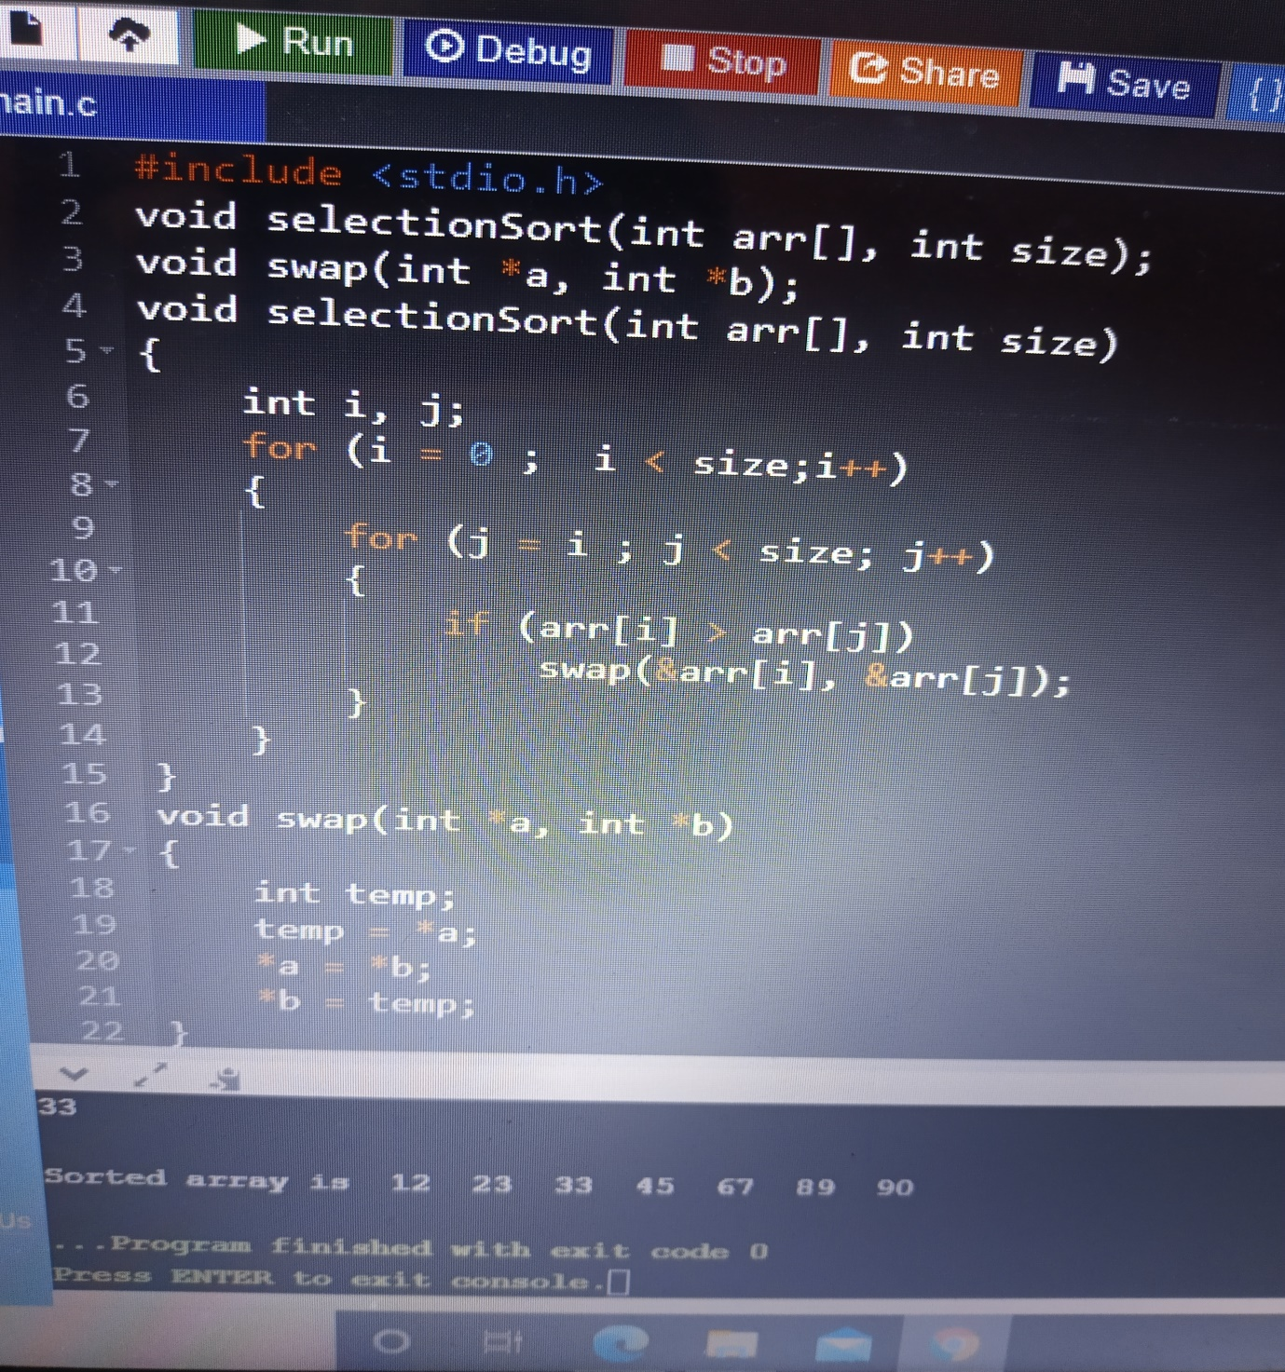

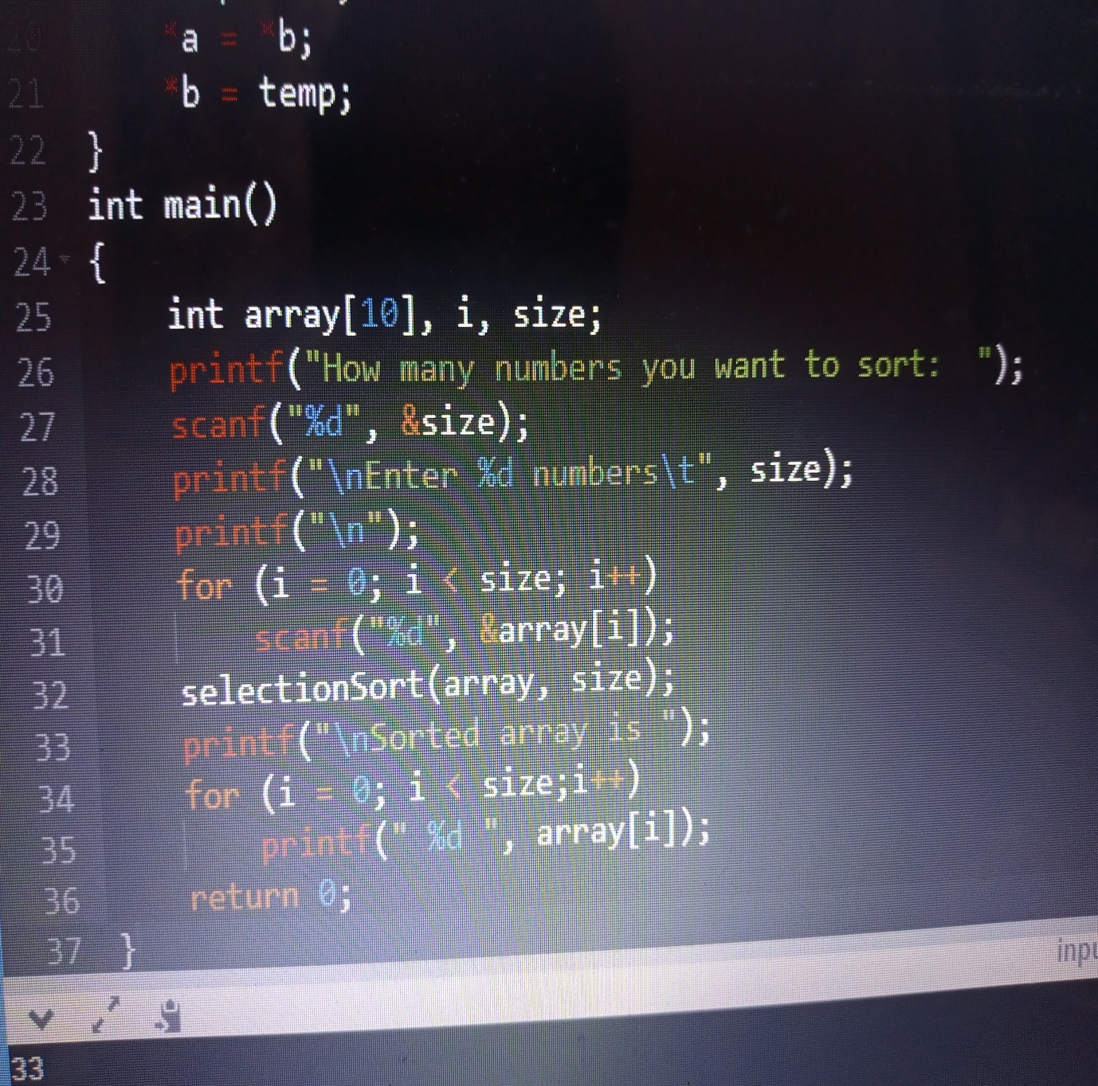

Output-

